Launch Tomcat container and display the output.

- Install docker and start docker
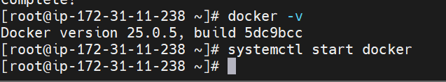
- Install Jenkins as war application
- Install tomcat and go to webapps and deploy Jenkins war file. And start tomcat.

[root@ip-172-31-2-6 webapps]# ll
total 93744
drwxrwxrwx 16 root root 4096 Nov 6 19:55 docs
drwxrwxrwx 7 root root 99 Nov 6 19:55 examples
drwxrwxrwx 6 root root 79 Nov 6 19:55 host-manager
-rw-r--r-- 1 root root 95987064 Sep 24 13:53 jenkins.war
drwxrwxrwx 6 root root 114 Nov 6 19:55 manager
drwxrwxrwx 3 root root 223 Nov 6 19:55 ROOT
[root@ip-172-31-2-6 webapps]# cd ..
[root@ip-172-31-2-6 apache-tomcat-9.0.97]# cd bin
[root@ip-172-31-2-6 bin]# ./startup.sh
Using CATALINA_BASE: /mnt/server/apache-tomcat-9.0.97
Using CATALINA_HOME: /mnt/server/apache-tomcat-9.0.97
Using CATALINA_TMPDIR: /mnt/server/apache-tomcat-9.0.97/temp
Using JRE_HOME: /usr
Using CLASSPATH: /mnt/server/apache-tomcat-9.0.97/bin/bootstrap.jar:/mnt/server/apache-tomcat-9.0.97/bin/tomcat-juli.jar
Using CATALINA_OPTS:
Tomcat started.
[root@ip-172-31-2-6 bin]#

- Create Dockerfile

FROM ubuntu
RUN apt-get update && apt-get -y install openjdk-11-jdk wget zip unzip
WORKDIR /tmp
ADD https://dlcdn.apache.org/tomcat/tomcat-9/v9.0.97/bin/apache-tomcat-9.0.97.zip /tmp
RUN unzip apache-tomcat-9.0.97.zip && chmod -R 777 apache-tomcat-9.0.97 && rm -rf apache-tomcat-9.0.97.zip
EXPOSE 8080
ENTRYPOINT [ "/tmp/apache-tomcat-9.0.97/bin/catalina.sh", "run" ]

- Build custom image

Docker build -t 412 tushar/tomcatjava11 dockerfile path

[root@ip-172-31-2-6 mnt]# docker build -t 412tushar/tomcatjava11 .
[+] Building 95.6s (10/10) FINISHED docker:default
=> [internal] load build definition from Dockerfile 0.1s
=> => transferring dockerfile: 408B 0.0s
=> [internal] load metadata for docker.io/library/ubuntu:latest 2.2s
=> [internal] load .dockerignore 0.0s
=> => transferring context: 2B 0.0s
=> [1/5] FROM docker.io/library/ubuntu:latest@sha256:278628f08d4979fb9af9ead44277dbc9c92c2465922310916ad0c46ec9999295 2.5s
=> => resolve docker.io/library/ubuntu:latest@sha256:278628f08d4979fb9af9ead44277dbc9c92c2465922310916ad0c46ec9999295 0.0s
=> => sha256:278628f08d4979fb9af9ead44277dbc9c92c2465922310916ad0c46ec9999295 6.69kB / 6.69kB 0.0s
=> => sha256:f470988096c4d77efac9740a1b6700823681af518a17fad30111430b95dfbffa 424B / 424B 0.0s
=> => sha256:fec8bfd95b54439b934c5033dc62d79b946291c327814f2d4df181e1d7536806 2.30kB / 2.30kB 0.0s
=> => sha256:afad30e59d72d5c8df4023014c983e457f21818971775c4224163595ec20b69f 29.75MB / 29.75MB 0.5s
=> => extracting sha256:afad30e59d72d5c8df4023014c983e457f21818971775c4224163595ec20b69f 1.7s
=> CACHED https://dlcdn.apache.org/tomcat/tomcat-9/v9.0.97/bin/apache-tomcat-9.0.97.zip 0.2s
=> [2/5] RUN apt-get update && apt-get -y install openjdk-11-jdk wget zip unzip 74.2s
=> [3/5] WORKDIR /tmp 0.1s
=> [4/5] ADD https://dlcdn.apache.org/tomcat/tomcat-9/v9.0.97/bin/apache-tomcat-9.0.97.zip /tmp 0.2s
=> [5/5] RUN unzip apache-tomcat-9.0.97.zip && chmod -R 777 apache-tomcat-9.0.97 && rm -rf apache-tomcat-9.0.97.zip 1.5s
=> exporting to image 14.5s
=> => exporting layers 14.5s
=> => writing image sha256:ff66eb86970cd9610b7f9971c9cf0a5ea14e5300cc01833ce9cfbf79c75fac81 0.0s
=> => naming to docker.io/412tushar/tomcatjava11 0.0s
[root@ip-172-31-2-6 mnt]#

- Push docker file on Dockerhub
[root@ip-172-31-2-6 mnt]# docker login
Log in with your Docker ID or email address to push and pull images from Docker Hub. If you don't have a Docker ID, head over to https://hub.docker.com/ to create one.
You can log in with your password or a Personal Access Token (PAT). Using a limited-scope PAT grants better security and is required for organizations using SSO. Learn more at https://docs.docker.com/go/access-tokens/

Username: 412tushar
Password:
WARNING! Your password will be stored unencrypted in /root/.docker/config.json.
Configure a credential helper to remove this warning. See
https://docs.docker.com/engine/reference/commandline/login/#credentials-store

Login Succeeded
[root@ip-172-31-2-6 mnt]# docker push 412tushar/tomcatjava11
Using default tag: latest
The push refers to repository [docker.io/412tushar/tomcatjava11]
c669974bb10f: Pushed
9ee2da6d8656: Pushed
5f70bf18a086: Pushed
e4a9008d1ecf: Pushed
27123a71e85e: Mounted from library/ubuntu
latest: digest: sha256:251287df12bc86ce8a9bbcbfbbf3a66c966ffe7dd73147ba2e0e4e1b6db312ca size: 1372

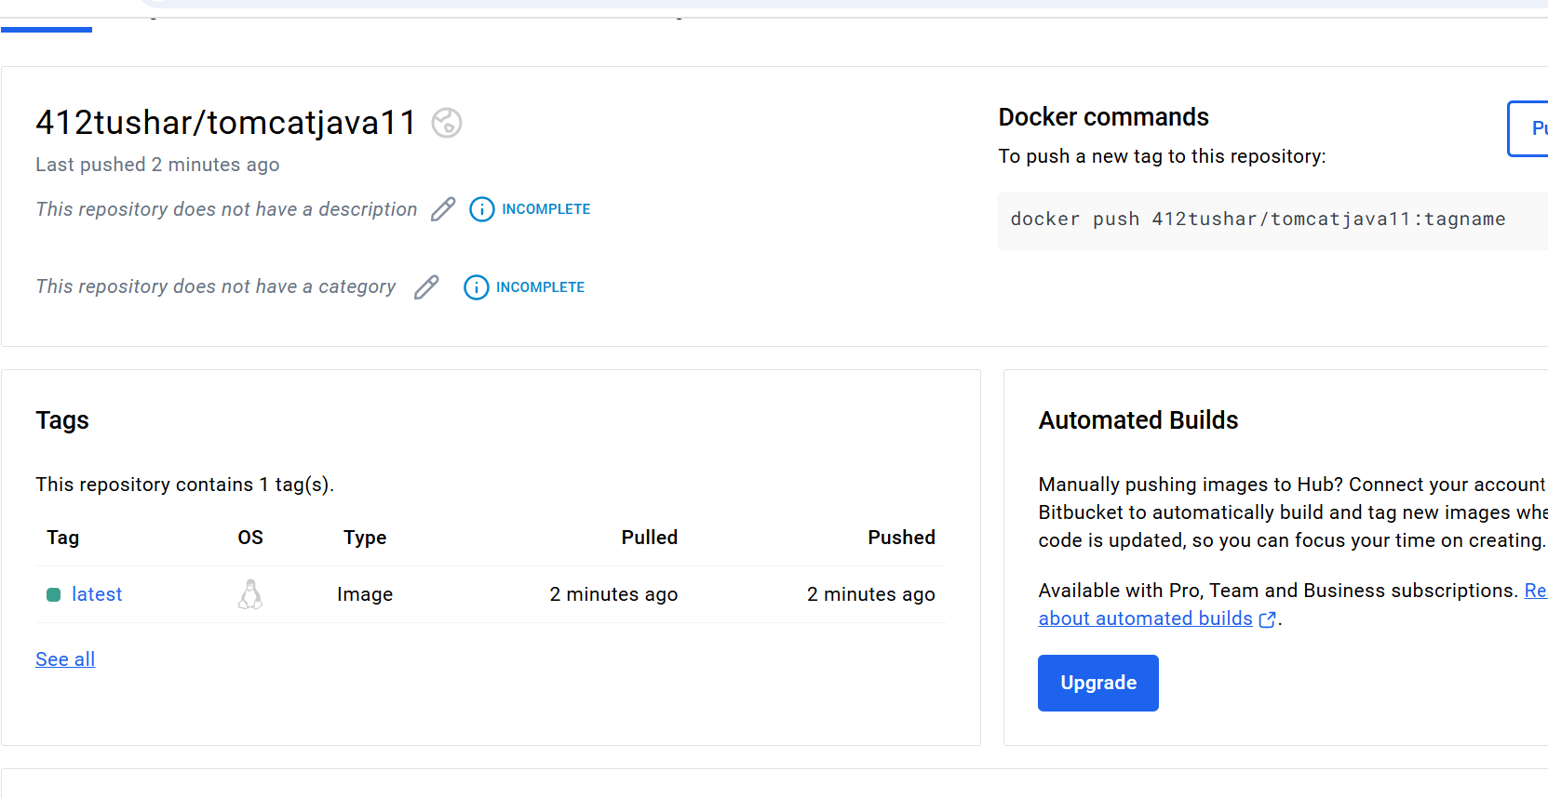

- Docker image pull from docker hub

[root@ip-172-31-2-6 mnt]# docker pull 412tushar/tomcatjava11
Using default tag: latest
latest: Pulling from 412tushar/tomcatjava11
afad30e59d72: Pull complete
4f9208a66330: Pull complete
4f4fb700ef54: Pull complete
37b18cd7f222: Pull complete
74366dd736ab: Pull complete
Digest: sha256:251287df12bc86ce8a9bbcbfbbf3a66c966ffe7dd73147ba2e0e4e1b6db312ca
Status: Downloaded newer image for 412tushar/tomcatjava11:latest
docker.io/412tushar/tomcatjava11:latest
[root@ip-172-31-2-6 mnt]#

- Create container through custom image
[root@ip-172-31-2-6 mnt]# docker run -itdp 8081:8080 412tushar/tomcatjava11
44d32bf3d7df5d88869850484d80e90c5cf63c9bfe1bf12528c3d0280529ada2
[root@ip-172-31-2-6 mnt]# docker ps
CONTAINER ID IMAGE COMMAND CREATED STATUS PORTS NAMES
44d32bf3d7df 412tushar/tomcatjava11 "/tmp/apache-tomcat-…" 5 seconds ago Up 4 seconds 0.0.0.0:8081->8080/tcp, :::8081->8080/tcp inspiring_lovelace

- Create Declarative pipeline and create build pieline
- pipeline{
- agent{
- label{
- label "tushar"
- }

- }

- stages{
- stage("clone github"){
- steps{
- sh '''
- cd /mnt
- sudo rm -rf loginwebapp
- sudo git clone https://github.com/jidnyasactc/loginwebapp.git
- '''
- }
- }
- stage("maven install"){
- steps{

- sh '''

- cd /mnt/loginwebapp/
- sudo chmod -R 777 /mnt/loginwebapp/
- export PATH="/mnt/server/apache-maven-3.9.9/bin:$PATH"
- mvn clean install
- '''
- }
- }
- stage("Copy"){
- steps{
- sh '''
- docker cp /mnt/loginwebapp/target/LoginWebApp.war 44d32bf3d7df:/tmp/apache-tomcat-9.0.97/webapps/
- '''
- }

- }
- }
- }

10. check build output

Started by user Tushar Chavan
[Pipeline] Start of Pipeline
[Pipeline] node
Running on Jenkins in /root/.jenkins/workspace/Docker 3
[Pipeline] {
[Pipeline] stage
[Pipeline] { (clone github)
[Pipeline] sh
+ cd /mnt
+ sudo rm -rf loginwebapp
+ sudo git clone https://github.com/jidnyasactc/loginwebapp.git
Cloning into 'loginwebapp'...
[Pipeline] }
[Pipeline] // stage
[Pipeline] stage
[Pipeline] { (maven install)
[Pipeline] sh
+ cd /mnt/loginwebapp/
+ sudo chmod -R 777 /mnt/loginwebapp/
+ export PATH=/mnt/server/apache-maven-3.9.9/bin:/mnt/server/apache-maven-3.9.9/bin:/usr/local/sbin:/usr/local/bin:/usr/sbin:/usr/bin:/root/bin
+ PATH=/mnt/server/apache-maven-3.9.9/bin:/mnt/server/apache-maven-3.9.9/bin:/usr/local/sbin:/usr/local/bin:/usr/sbin:/usr/bin:/root/bin
+ mvn clean install
NOTE: Picked up JDK_JAVA_OPTIONS: --add-opens=java.base/java.lang=ALL-UNNAMED --add-opens=java.base/java.io=ALL-UNNAMED --add-opens=java.base/java.util=ALL-UNNAMED --add-opens=java.base/java.util.concurrent=ALL-UNNAMED --add-opens=java.rmi/sun.rmi.transport=ALL-UNNAMED
[INFO] Scanning for projects...
[INFO]
[INFO] --------------------< com.javawebtutor:LoginWebApp >--------------------
[INFO] Building LoginWebApp Maven Webapp 1.0-SNAPSHOT
[INFO] from pom.xml
[INFO] --------------------------------[ war ]---------------------------------
[INFO]
[INFO] --- clean:3.2.0:clean (default-clean) @ LoginWebApp ---
[INFO]
[INFO] --- resources:3.3.1:resources (default-resources) @ LoginWebApp ---
[WARNING] Using platform encoding (UTF-8 actually) to copy filtered resources, i.e. build is platform dependent!
[INFO] skip non existing resourceDirectory /mnt/loginwebapp/src/main/resources
[INFO]
[INFO] --- compiler:3.13.0:compile (default-compile) @ LoginWebApp ---
[INFO] No sources to compile
[INFO]
[INFO] --- resources:3.3.1:testResources (default-testResources) @ LoginWebApp ---
[WARNING] Using platform encoding (UTF-8 actually) to copy filtered resources, i.e. build is platform dependent!
[INFO] skip non existing resourceDirectory /mnt/loginwebapp/src/test/resources
[INFO]
[INFO] --- compiler:3.13.0:testCompile (default-testCompile) @ LoginWebApp ---
[INFO] No sources to compile
[INFO]
[INFO] --- surefire:3.2.5:test (default-test) @ LoginWebApp ---
[INFO] No tests to run.
[INFO]
[INFO] --- war:3.4.0:war (default-war) @ LoginWebApp ---
[INFO] Packaging webapp
[INFO] Assembling webapp [LoginWebApp] in [/mnt/loginwebapp/target/LoginWebApp]
[INFO] Processing war project
[INFO] Copying webapp resources [/mnt/loginwebapp/src/main/webapp]
[INFO] Building war: /mnt/loginwebapp/target/LoginWebApp.war
[INFO]
[INFO] --- install:3.1.2:install (default-install) @ LoginWebApp ---
[INFO] Installing /mnt/loginwebapp/pom.xml to /root/.m2/repository/com/javawebtutor/LoginWebApp/1.0-SNAPSHOT/LoginWebApp-1.0-SNAPSHOT.pom
[INFO] Installing /mnt/loginwebapp/target/LoginWebApp.war to /root/.m2/repository/com/javawebtutor/LoginWebApp/1.0-SNAPSHOT/LoginWebApp-1.0-SNAPSHOT.war
[INFO] ------------------------------------------------------------------------
[INFO] BUILD SUCCESS
[INFO] ------------------------------------------------------------------------
[INFO] Total time: 5.378 s
[INFO] Finished at: 2024-11-20T07:47:19Z
[INFO] ------------------------------------------------------------------------
[Pipeline] }
[Pipeline] // stage
[Pipeline] stage
[Pipeline] { (Copy)
[Pipeline] sh
+ docker cp /mnt/loginwebapp/target/LoginWebApp.war 7a1388620f11:/tmp/apache-tomcat-9.0.97/webapps/
[Pipeline] }
[Pipeline] // stage
[Pipeline] }
[Pipeline] // node
[Pipeline] End of Pipeline
Finished: SUCCESS

11. hit IP address in the http://3.94.81.139:8081/LoginWebApp/

